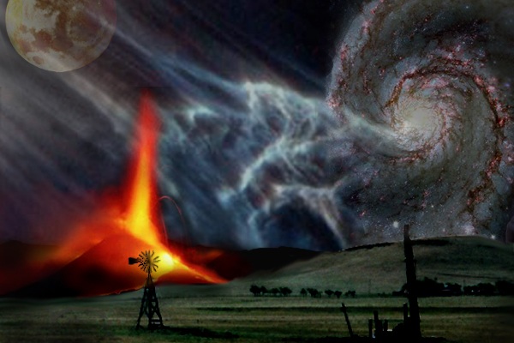
Earth Science Syllabus - Term 1

All items are subject to change without notice
Syllabus does not include quizzes

Unit 1: Review the Basics DUE
Aug 22 Documents, Procedure, Overview
Aug 24 Review Science / Safety
Aug 27 Practical review, Metrics
Aug 29 Numbers in science Disclosure Document
Aug 31 Activity (Measure-lab) Science and Safety
Sep 5 Review Metrics Assignment
Sep 7 Mini-test Numbers in Science, Lab

Unit 2: Astronomy, History, and Our Solar System
Sep 10 Look up! History, Earth-moon-sun
Sep 12 Chapter 22 review, 639 1-30
Sep 14 Solar System, formation
Sep 17 The Planets Scientist Chart, Moon Chart
Sep 19 Other members Ch 22 Review p. 639 1-30
Sep 21 Chapter 23 review, 669 1-30 Temperature Chart p. 648
Sep 24 Review Planet Comparison
Sep 26 Test Comet Picture

Unit 3: Sun, Stars, and the Universe
Sep 28 Light (prisms and doppler) Ch 23 Review p. 669 1-30
Oct 1 Telescopes, Sun
Oct 3 Chapter 24 Review, 695 1-30 PROJECT: Solar System
Oct 5 Stars Light Chart
Oct 8 Stellar evolution and the Big Bang Sun map
Oct 10 Chapter 25 review, 725 1-30 Ch 24 Review p. 695 1-30
Oct 15 Project H-R Diagram
Oct 17 Review Star Evolution Worksheet
Oct 19 TEST Ch. 25 Review p. 725 1-30
Oct 22 Make Up
Oct 24 Gravity, dimensions DROP DEAD DAY!!!
Oct 26 Intro Earth Structure

