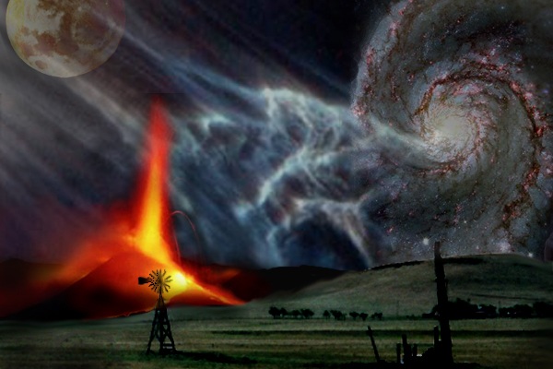
Earth Science Syllabus - Term 4

All items are subject to change without notice
Syllabus does not include quizzes

Unit 1: Geologic Time and Weathering DUE
Mar 18 The Atmosphere
Mar 20 Sun, Heat, Light, and Water
Mar 22 Chapter 17, p. 449 1-24, Test 1-6
Mar 25 Humidity and Lifting Atmosphere Chart p. 480
Mar 27 Cloud Types and Precipitation Weather Elements Wksheet
Mar 29 Chapter 18, p. 527 1-27, Test 1-3 Ch 17, p. 449 1-24, Test 1-6
Apr 8 Wind Cloud Bottle Writeup
Apr 10 Prevailing and Regional Winds Cloud Pictures
Apr 12 Air Masses and Weather, Fronts Ch 18, p. 527 1-27, Test 1-3
Apr 15 Fronts and Severe Storms (movies)
Apr 17 Chapters 19, 20, 553 +583,1-15 ea Wind Maps
Apr 19 Climate Overview Fronts Worksheet
Apr 22 Climate Changes
Apr 24 Review Ch 19,20 553, 583 1-15 ea
Apr 26 Test Climate Worksheet

Unit 2: Water and Oceans DUE
Apr 29 Review
May 1 Review
May 3 Review
May 6 CRT TESTING
May 8 CRT TESTING
May 10 Make Up Day
May 13 Wow Me WOW ME PROJECT DUE
May 15 Wow Me
May 17 Wow Me
May 20 Wow Me + Clean DROP DEAD DAY!!!
May 22 Activities Outside Wow Me Writeup Due
May 24 Last Day of School

