Name______________________________________________________
Cell Quiz

What are the four organic macromolecules

1. _____________________________________ 2. ________________________________

3. _____________________________________ 4. ________________________________

For each description, write the name of the organelle

1. Control center of the cell that houses information _______________________________________

2. Outer container of all cells _________________________________________________________

3. Energy center of cell – breaks apart sugar molecules ____________________________________

4. “Highway” of the cell and comes in smooth and rough __________________________________

5. Shipping and packaging center _____________________________________________________

6. Protein manufacturing places _______________________________________________________

7. Makes the protein makers – inside the center ___________________________________________

8. Digests and dissolves _____________________________________________________________

9. Container that may hold water _____________________________________________________

10. Long strings of information _______________________________________________________

11. Separates the center from the rest of the cell __________________________________________

12. Liquid inside a cell ______________________________________________________________

13. In plants: makes sugars with the help of sunlight _______________________________________

14. In plants: Protects the cell and gives structure _________________________________________

15. In animals: Very short projections that cause movement _________________________________

16. In animals: A long, tail-like projection for movement ___________________________________

17. What are membranes made of? _____________________________________________________

18. What is the purpose of proteins in the membrane? ______________________________________

____________________________________________________________________________

List at least two parts of cell theory:

1. __________________________________________________________________________

2. __________________________________________________________________________

Microtubules and Microfilaments are parts of the cytoskeleton. What is a cytoskeleton?

____________________________________________________________________________

When cells are hypotonic, water flows into the cell and it swells. When a cell is hypertonic, what happens?
______________________________________________________________________

What does a rough ER make? _________________________________________________________

What does a smooth ER make? ________________________________________________________

Name at least two parts of a cell made from a phospholipid bilayer

1. _________________________________________________________________________

2. _________________________________________________________________________

Plants and animals are made of eukaryotic cells. What is eukaryotic?

____________________________________________________________________________

How can you tell if a cell is eukaryotic? _________________________________________________

____________________________________________________________________________

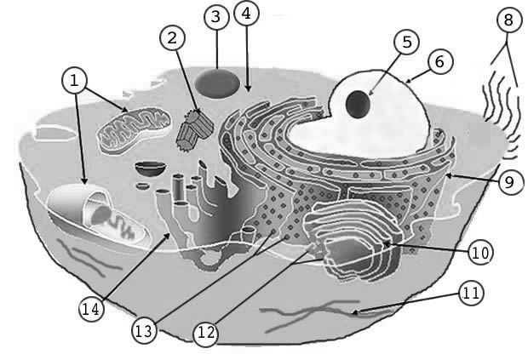
Label at least eight (8) parts of this cell:

