Name ___________________________ | Period ________
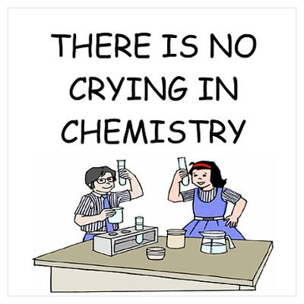 | Chemistry Test #2  Memorized Section  List 15 elements from the periodic table with their atomic numbers and chemical symbols. | 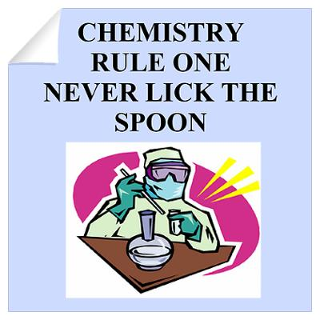

Atomic Number | Chemical Name | Symbol
EXTRA CREDIT: On the back, list any additional elements with their names and numbers.

