Name ______________________________________ Period ________________

Chemistry Basics Test 2013

Procedure
1. What is the website for the class? ____________________________________________

2. Where do completed assignments go? ________________________________________

Safety
3. What should be done if you accidentally break glassware?

__________________________________________________________

____________________________________________________________

Scientific Method
4. What needs to happen before a hypothesis is made? _________________________

____________________________________________________________________________

5. What is a hypothesis? ________________________________________________________

6. What must you do after your hypothesis? ____________________________________

____________________________________________________________________________

7. What does it mean to evaluate your work? __________________________________

_____________________________________________________________________________
Metrics
8. How did scientists invent the meter? _______________________________________

9. How did scientists invent the liter? _________________________________________

10. How did scientists invent the gram? ________________________________________

11. What is metric temperature based on? ______________________________________

12-15. Fill in the following table. Get all four blanks.

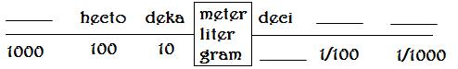
Convert the following:
16. 53 centigrams into grams ____________________________________________

17. 27 kiloliters into liters ________________________________________________

18. 100 millimeters into meters __________________________________________

19. 7 grams into milligrams ______________________________________________

20. 87 centimeters into millimeters ______________________________________
Abbreviate the following:

21. centimeter _____________________

22. kilogram _______________________

23. Liter ___________________________

24. Degrees Celsius ________________

Significant Figures – How many significant figures are in the following:

25. 370.004

26. 0.0023

27. 75.0000

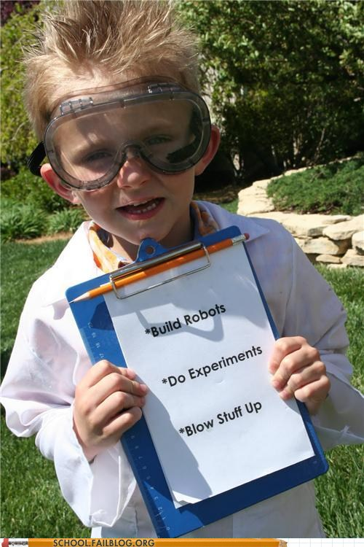
28. 200

Rounding: Round the numbers to the one's place.

29 . 24.53

30. 31.5

31. 16.5

Scientific Notation
Convert the following to scientific notation

32. 23,000,000,000

33. 0.000000478

34. 0.023

35. 6702
Change the following from scientific notation to a standard number.

36. 6.29 x 10⁵

37. 4.1 x 10⁻³

38. 5x10¹²

Add the following:
39. 5 x 10⁻¹²
+ 2 x 10⁻¹²

40. 8 x 10⁵
+ 9 x 10⁵

41. 4 x 10¹⁸
+ 3 x 10¹⁷

42. 9 x 10⁻²³
+ 8 x 10⁻²¹

Multiply the following:
42. 2 x 10¹⁶
x 4 x 10³

43. 7 x 10⁻⁶
x 5 x 10¹⁰

44. 3 x 10⁻¹⁵
x 4 x 10⁻⁷

Basic Matter – Label the following atom with the correct particles, 45-47
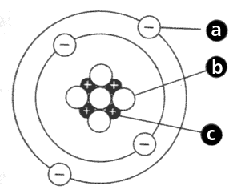
Place the following in the correct order (number from one to seven) 48-54
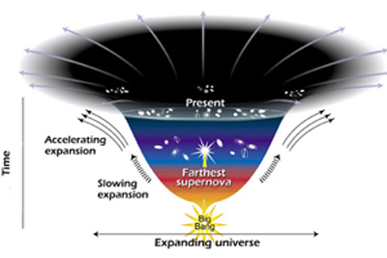
_____ Formation of light elements

_____ Formation of neutrons

_____ Formation of stars

_____ Formation of electrons

_____ Formation of heavy elements

_____ Formation of protons

_____ Formation of our planet

55. What is the approximate date of the “big bang”? ____________________________

Match the following times and people with events. Each may be used more than once.

_____ 56. Before 300 B.C., ancient Greek A. Bohr, Niels
B. de Broglie, Louis
_____ 57. 1909, shot gold with electrons C. Dalton, John
D. Demosthenes
_____ 58. Late 1920s, electron cloud E. Rutherford, Ernest
F. Thompson, J.J.
_____ 61. Early 1800's modern atomic theory

_____ 59. 1913, model of atom with orbitals and neutrons

_____ 60. 1897, discovered electrons, “chocolate chip” model

_____ 62. Coined the term “atomos” meaning indestructible

_____ 63. Determined the precise location of electrons are impossible to locate

_____ 64. Discovered the nucleus and found atoms mostly empty space

_____ 65. Proposed that all atoms of lead are alike, neon are alike, but lead atoms are not like neon atoms
On the counter, match the lab equipment with the correct name.
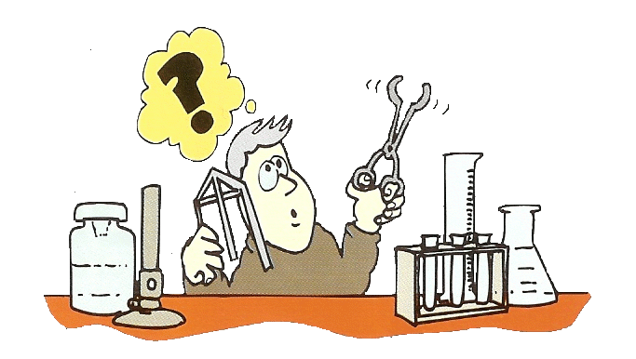
_____ 66. graduated cylinder

_____ 67. pipette

_____ 68. Florence flask

_____ 69. Erlenmeyer flask

_____ 70. volumetric flask

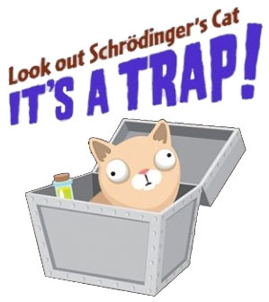
_____ 71. beaker

_____ 72. balance scale

_____ 73. alcohol burner

_____ 74. support stand

_____ 75. ring clamp

_____ 76. test tube clamp

_____ 77. test tube
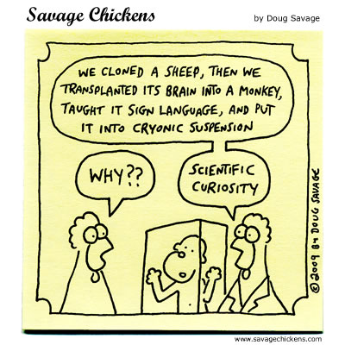
_____ 78. test tube rack

_____ 79. crucible

_____ 80. mortar and pestle

_____ 81. tweezers

_____ 82. tongs

_____ 83. funnel

_____ 84. petri dish

_____ 85. wire mesh

BONUS
* Explain the difference between a petri dish and an evaporating dish (watch glass)

* Explain the difference between an alcohol burner and a Bunsen burner

