Name _________________________________________ Period __________
Test 2
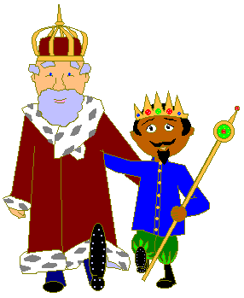
1. What is used to measure VOLUME in the metric system?
A. kilometers and meters
B. milliliters and liters
C. kilograms and grams
D. cups and gallons
E. miles and feet?
2. According to the story of the king’s feet, why doesn’t most of the world use the English system?
A. Not everyone has feet
B. Not everyone has a stick
C. Not everyone uses measurements
D. Not everyone likes using the English King's system
3. What is used to measure LENGTH in the metric system?
A. kilometers and meters
B. milliliters and liters
C. kilograms and grams
D. cups and gallons
E. miles and feet
4. True/False Most Americans commonly use metric lengths. _____
5. What is used to measure MASS in the metric system?
A. kilometers and meters
B. milliliters and liters
C. kilograms and grams
D. cups and gallons
E. ounces and pounds
6. What unit is used to measure TEMPERATURE in the metric system?
____________________________________________________________________
7. Match each metric unit with how it was invented.
A. divided the distance from pole to the equator by 10,000,000 | W. Liter
B. calculated the mass for a cubic centimeter of water | X. Meter
C. discovered the volume for 1000 cubic centimeters of water | Y. Celsius
D. calculated freezing and boiling at sea level | Z. Gram
8. Two of the most common metric lengths you'll use are meters and millimeters. What are the other two most common metric lengths?
____________________________ ______________________________ /12
9. Besides grams, what are the two most common units of mass?
___________________________ ______________________________
10. Besides liters, what are the two most common units of volume?
___________________________ ______________________________
11. How does most of the world spell meter? ______________________________
12. What is one way to measure length that is not used anymore?
A. miles
B. kilometers
C. yards
D. cubits
E. centimeters
13. Fill out the following table:
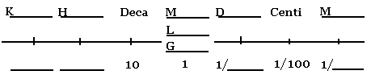
14. Do the following conversions:
23457 centimeters to meters ______________________________________
39.87 liters to hectoliters _________________________________________
305.55 milligrams to grams _______________________________________
2.43 kilometers to meters _________________________________________
2.43 meters to kilometers ________________________________________
15. What weighs about a gram?
A. a chair
B. a science book
C. a piece of paper
D. you
16. Which of these is about a meter?
A. the width of your hand
B. the height up to a doorknob
C. the length of this room
D. the width of your little finger /24
17. Which has a volume of about a liter?
A. A 1000 mL beaker
B. A 50 mL flask
C. A 100 mL cylinder
D. A 2000 mL bottle
18. Write next to each metric unit its correct abbreviation. Be careful. Don’t let the box mess you up.
Liter ____________  Meter ____________  Gram ____________  Centiliter ____________  Milligram ____________  Kilometer ____________ |  | l.  L.  Lit.  lit.  Ltr.  ltr.  m.  M.  Met.  met.  Mtr. | mtr.  g.  G.  Gra.  gra.  Grm.  grm.  cl.  Cl.  cL.  centi | cm.  cg.  cgrm.  cltr.  CL.  mG.  mg.  mm.  mM.  mL.  cgm. | mg.  Mg.  MG.  mG.  millig.  km.  KM.  kM.  kL  kg.  kC.
19. When reading a science textbook, which is LEAST important to read?
A. Picture captions
B. Subject headings
C. Introductory paragraph
D. Bold words

20. Use your knowledge of Latin and Greek to match the following known words

_____ A. thermometer P. small sound
_____ B. photograph Q. look inside
_____ C. microphone R. two circles
_____ D. endoscope S. light writing
_____ E. bicycle T. measure temperature
_____ F. transport U. carry across

21. Use your knowledge to determine the following fiction words.

_____ A. hypermorph V. three moon
_____ B. triluna W. super/ above change
_____ C. hydrovore X. know other
_____ D. megaterra Y. water eater
_____ E. heterosci Z. large earth

22. Why are Greek and Latin used so much in science?

____________________________________________________________________________
/20
Read the following graph and answer the questions
PRECIPITATION MEASURED EVERY TWO WEEKS
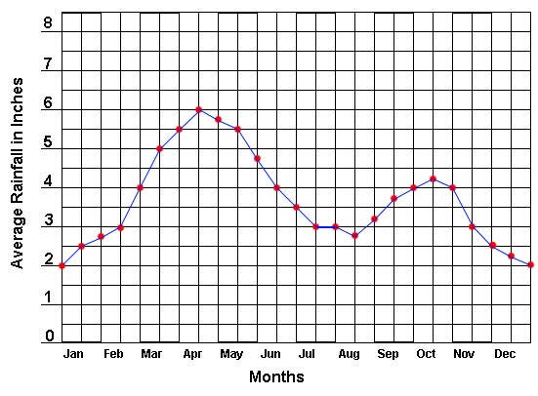

23. What does the x-axis represent?
A. Average Rainfall in Inches
B. Months
C. 0-8
D. Jan – Dec
E. Cannot be determined

24. What does the y-axis represent?
A. Average Rainfall in Inches
B. Months
C. 0-8
D. Jan – Dec
E. Cannot be determined

25. Which season is the driest?
A. Spring
B. Summer
C. Fall
D. Winter
E. Cannot be determined

26. What is the highest amount of rainfall that fell in a single two-week period?

_______________________________________________________________________ /4
27. Label the microcscope using the following words
arm
base or foot
coarse focus
diaphragm or iris
eyepiece
fine focus
high-power objective lens
light source
low-power objective lens
medium-power
objective lens
stage
stage clip

BONUS
body
eyepiece tube
nosepiece

28. What is the proper way to hold a microscope?

____________________________________________________________________________

29. What is the proper way to unplug a microscope?

____________________________________________________________________________

30. Why shouldn't you start focusing on high power?

_____________________________________________________________________________

/15

