Name _____________________________________ /50 (One bonus)

Earthquakes and Earth’s Interior
1. Match the definition with the term

_____ Fault A. A small earthquake the occurs before a bigger one

_____ Focus B. The center of an earthquake, often deep in the ground

_____ Epicenter C. A crack in the earth’s crust

_____ Foreshock D. An earthquake that follows a bigger one

_____ Aftershock E. The spot on earth’s surface directly above an quake center

2. Describe how the elastic rebound hypothesis explains earthquakes.

_______________________________________________________________________________

_______________________________________________________________________________

3. Match the type of wave to its description

_____ P Wave F. A rolling wave that does not travel through the earth’s mantle

_____ S Wave G. The fastest wave, traveling like a compressed spring, or pulse

_____ Surface Wave H. Medium speed wave characterized by an up-down motion
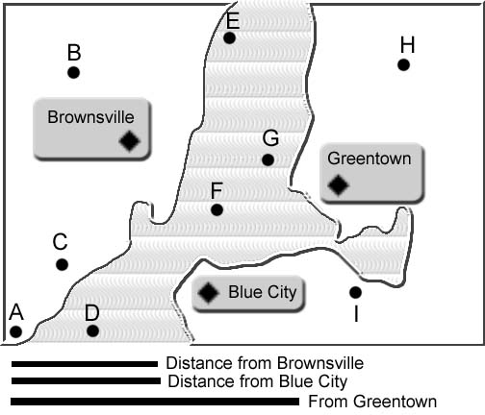
4. Seismographs are located in Brownsville, Greentown, and Blue City. Each record a quake, and determined the distance from the city center (see bottom of the picture). Use the picture to determine which letter marks the epicenter of the quake.

The epicenter is located at
which letter?

_______________

5. Do earthquakes happen at the center of tectonic plates, or the edges? _________________
/11
6. Match the type of the quake to the approximate magnitude

_____ Magnitude 2 J. 100% destruction, more than any measured quake

_____ Magnitude 4 K. Cannot be felt, a very small quake

_____ Magnitude 6 L. May be lightly felt, no damage

_____ Magnitude 8 M. Strongly felt, great damage to buildings

_____ Magnitude 10 N. Moderate quake, some damage occurs

7. _______ T/F Earthquakes between 4-6 on the Richter Scale are the most common

8. What is liquefaction? _______________________________________________________________

_______________________________________________________________________________

9. What is a tsunami? _________________________________________________________________

_______________________________________________________________________________

10. Explain how earthquakes can cause fires ___________________________________________

_______________________________________________________________________________

11. Which of the following is true regarding earthquake predictions?
O. Scientists can predict earthquakes accurately
P. Scientists can make short-term predictions, but not long-term
Q. Scientists can make long-term predictions, but not short-term
R. Nothing about earthquakes are predictable

12. What and where is the lithosphere? (2)_____________________________________________

_______________________________________________________________________________

13. What and where is the asthenosphere? (2) __________________________________________

_______________________________________________________________________________

14. Which diagram of earth’s layers is most accurate regarding the width of layers? Black is
the crust, grey is the mantle, and white is the core (both outer and inner core),

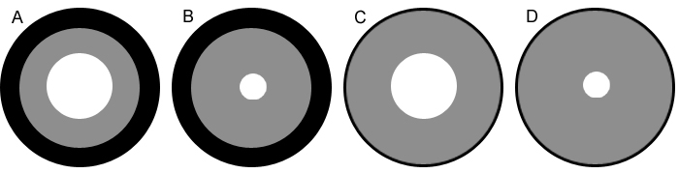
/15
15. What is the inner core made from? _________________________________________________

16. What can humans do to lessen the effects of an earthquake?

_______________________________________________________________________________
The Motion of Plates
17. What was Alfred Wegener famous for? _____________________________________________

_______________________________________________________________________________

18. Which of the following is NOT evidence Wegener used for his hypothesis?
Q. The continents fit together
R. Earth’s mantle is in motion
S. Fossils on different continents match
T. Similar rock structures, such as ancient mountains
U. Ancient climates (like glaciers) match

19. Summarize the theory of plate tectonics. ____________________________________________

_______________________________________________________________________________

20. Match the following plate boundaries with their definition

_____ Divergent V. Two plates sliding or grinding past each other
_____ Convergent W. Two plates moving away from each other

_____ Transform fault X. Two plates moving toward each other

21. Label on the map ONE OF EACH. Simply place the letter on the map.
A. Divergent ocean/ocean boundary
B. Convergent ocean/continental boundary
C. Transform fault boundary
D. Convergent continental/continental boundary
E. Divergent continental/continental boundary
F. Convergent ocean/ocean boundary
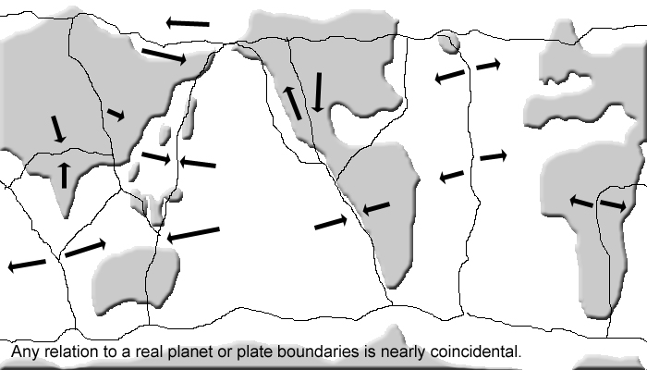

/14

22. What is Pangaea? ________________________________________________________________

______________________________________________________________________________

23. Which of the following is NOT associated with divergent boundaries
G. Subduction zone
H. Rift valley
I. Mid-ocean ridge
J. Sea-floor spreading

24. Which of the following is NOT associated with convergent boundaries
K. Ocean trench,
L. Volcanic arc
M. Subduction zone
N. Mid-ocean ridge

25. The Himalayas in India (and Nepal and Tibet) were the result of…
P. Oceanic plate colliding with oceanic plate
Q. Continental-Continental collision
R. Continental volcanic arc
S. Slip-strike fault

26. How can magnetism in the rocks help prove the plate tectonic theory? ________________

______________________________________________________________________________

27. What is a hot spot? _______________________________________________________________

_______________________________________________________________________________

28. Where is one of earth's hot spots? __________________________________________________

29. What causes earth’s plates to move? ________________________________________________

_______________________________________________________________________________

30. If new crust is being added at mid-ocean ridges, why is earth not getting bigger?

_____________________________________________________________________________

31. Explain how earthquake waves reveal the earth's layers. Be specific.

______________________________________________________________________________

______________________________________________________________________________

/10
EXTRA CREDIT: What is a moho?

